Project Design Document

1. Design Intent
The goal of this project is to create a 4-legged spider robot capable of walking and reacting to its environment. The robot is designed to move forward in a coordinated gait and stop or change direction when it detects an obstacle.
The experience being created is an interactive robotic system that mimics basic autonomous behavior.

2. Inspiration & References
- The project is inspired by existing quadruped and spider robots available online, particularly open-source designs that demonstrate walking mechanisms using servo motors.
- 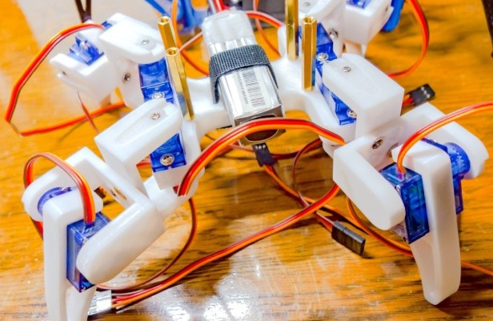Images / links
• Gait coordination: Stable walking requires coordinating diagonal legs (diagonal gait) so at least two legs remain on the ground at all times.
• Servo control strategy: Using a dedicated driver (PCA9685) is essential to control multiple servos smoothly without overloading the microcontroller.
• Mechanical design: Proper leg geometry and servo placement directly affect balance, range of motion, and overall stability.
• Power management: Servo motors require a separate 5V power source to avoid voltage drops and system resets.

3. User Journey
The user powers on the robot-
The robot initializes and starts in a standing position
The robot begins walking forward automatically
The ultrasonic sensor continuously checks for obstacles
If no obstacle is detected, the robot continues moving
If an obstacle is detected, the robot stops or changes direction
The robot resumes movement after avoiding the obstacle

4. Success Criteria
Define measurable success:
Functional:
- Robot can walk forward
- Robot detects obstacles within a fixed range
- Response time is less than 2 second
User Experience:
- Movement appears stable and coordinated
- System behaves predictably
Reliability:
- No sudden resets due to power issues
- Servos operate consistently without jitter

5. System Overview
The system consists of an ESP32 microcontroller, a PCA9685 servo driver, multiple servo motors, and an ultrasonic sensor.
The ESP32 processes input from the ultrasonic sensor and sends control signals to the servo driver. The PCA9685 controls the movement of all servo motors, enabling coordinated walking of the robot.

6. High-Level Block Diagram
👉 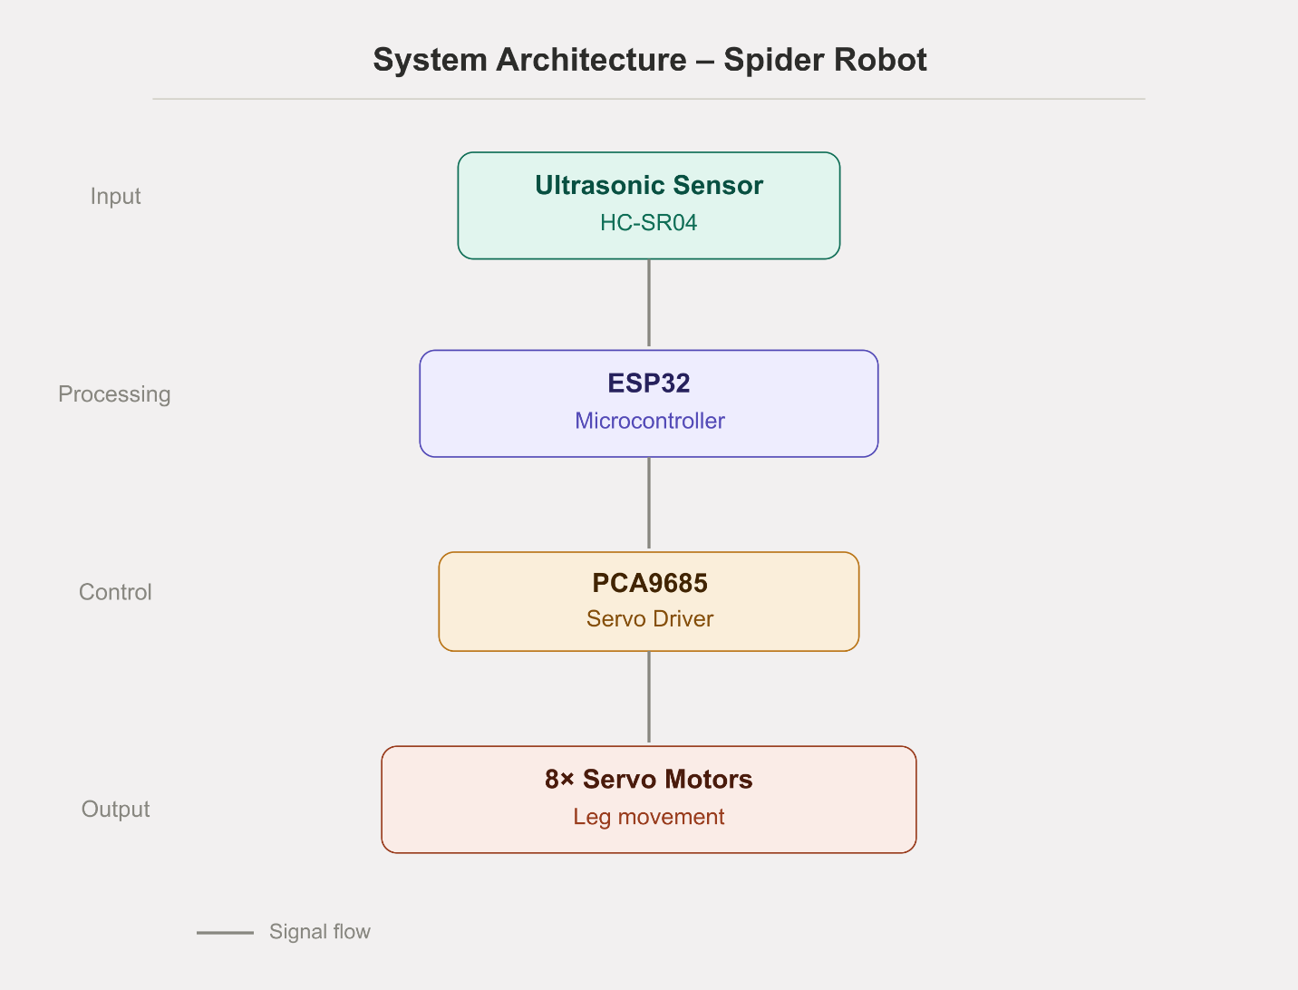

7. Input / Output Mapping
Input | Process |  | Output
Ultrasonic Sensor | ESP32 processes distance data |  | Servo motors move robot
Distance < threshold |  | Decision logic triggers | Robot stops / changes direction
Distance > threshold | Normal walking logic |  | Robot moves forward

8. Sketches & Concepts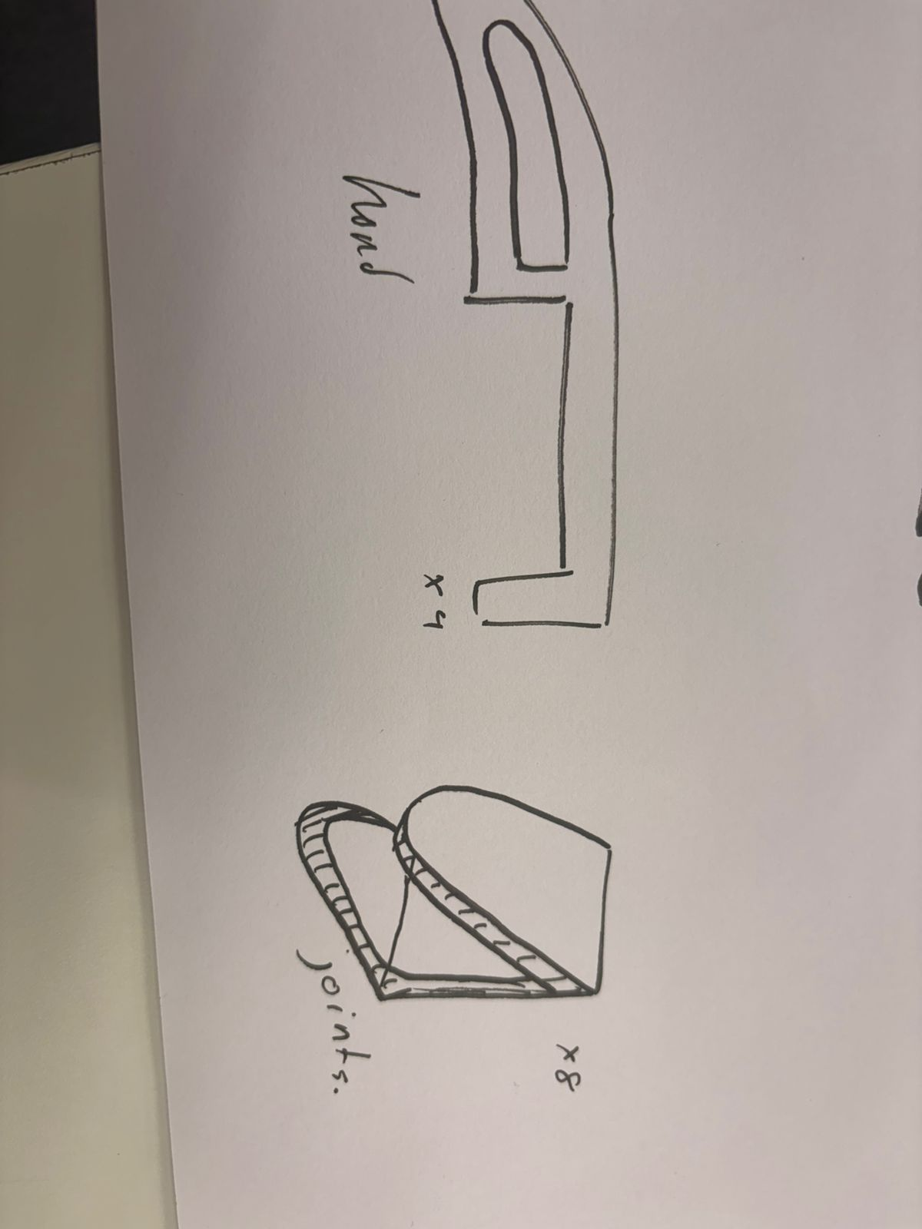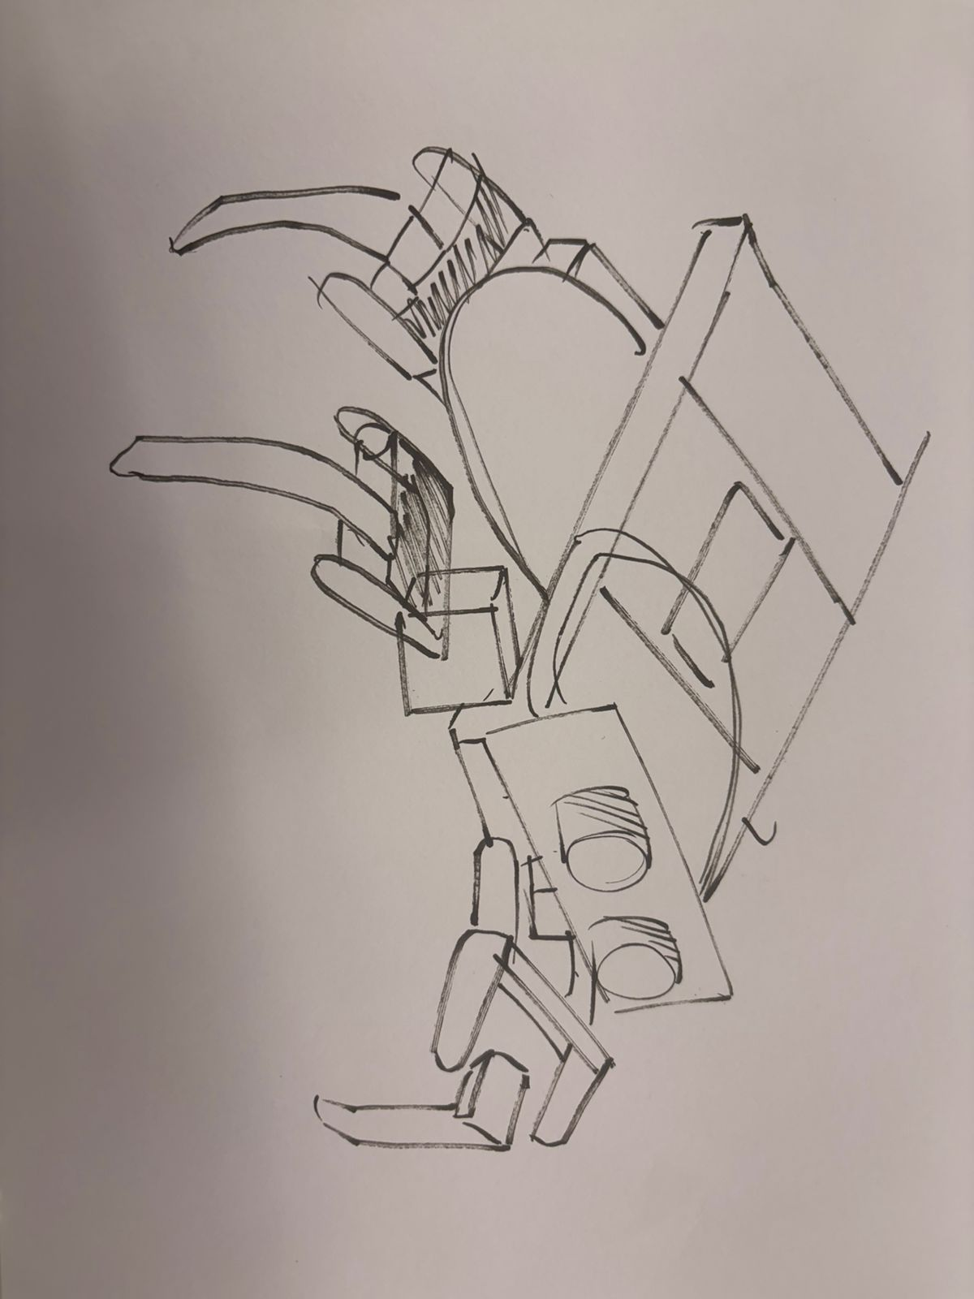
- Iterations
- 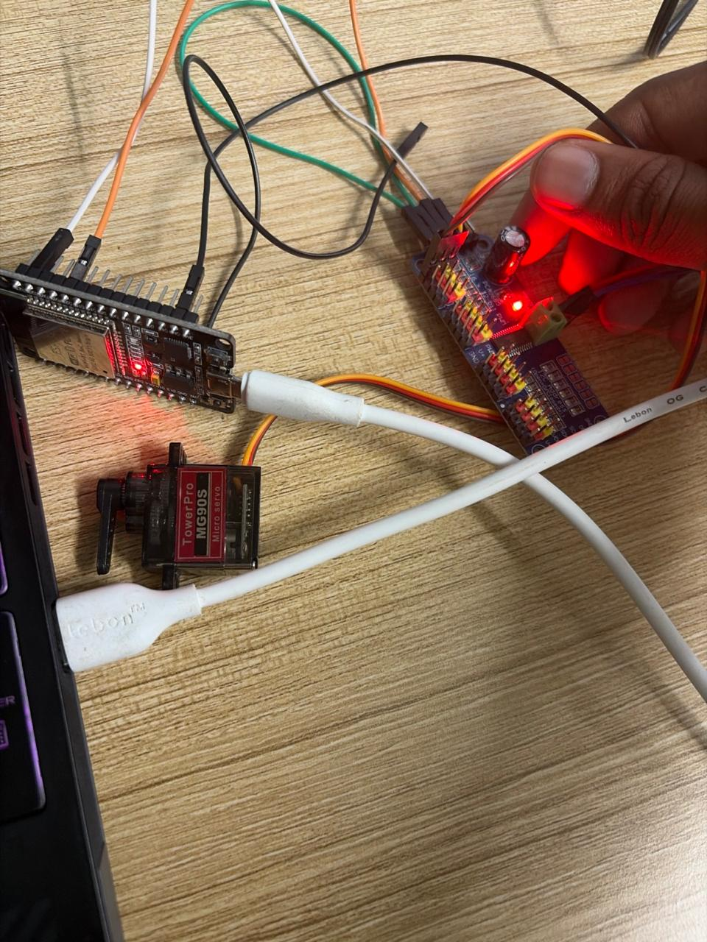

9. Final System Architecture (Labelled)
👉 The final system architecture shows how the ultrasonic sensor provides input to the ESP32, which processes the data and sends control signals to the PCA9685 servo driver. The servo driver then controls the servo motors to produce movement. This structure ensures efficient communication and coordinated operation of the robot.
Concept
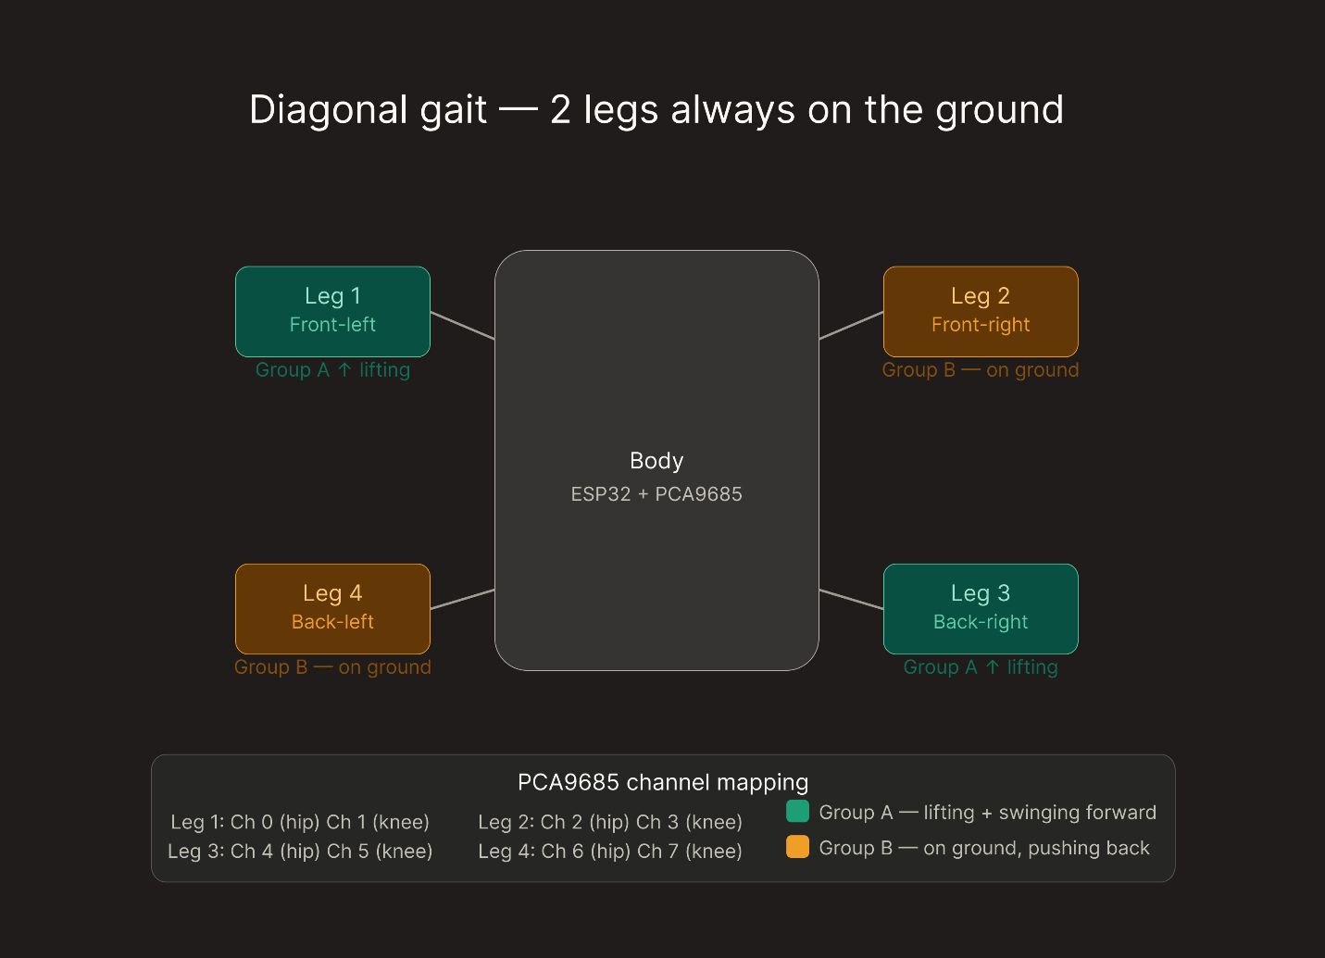
This diagram represents the development of the walking mechanism, showing how diagonal gait was used to maintain stability. It helped in understanding how legs should move in coordination.

Final System Architecture
This diagram represents the development of the walking mechanism, showing how diagonal gait was used to maintain stability. It helped in understanding how legs should move in coordination.

